**ELECTIVE 3: FULLSTACK WEB DEVELOPMENT**

**PRELIMINARY EXAMINATION**

**1st Semester, Academic Year 2019-2020**

Please follow the directions for each section. Note that in each section you will have some amount of choice in the questions you’ll be answering. The exam is based on a 100-point scale. Partial credit will be given for answers that are done partially well.

**Programming** (50 points ).

1. Create a basic website (without JavaScript) that has the following layout below with the ff. Instructions
   1. Should be posted in Github with the format E3PE_LASTNAME_FIRSTNAME for the project name.
   2. Follow layout below:

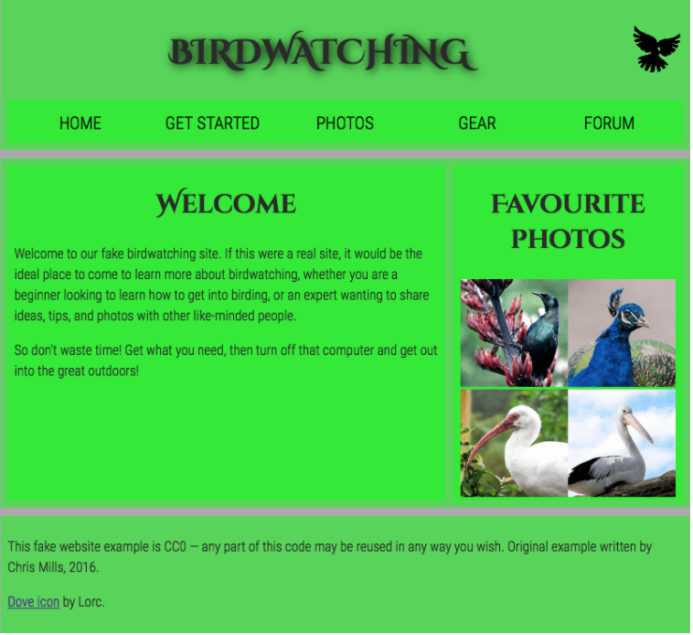

* 1. Logos and pictures can be changed.
  2. Fonts can be altered.

**Essay** (25 points):

1. How would you say that front-end development has evolved over the years? State some key difference from then (like 10 years ago) to now.
2. Provide a code snippet that shows CSS precedence between element selectors, class selectors and inline styling.

|  |  |  |
| --- | --- | --- |
| Prepared By:  NINO FRANCISCO ALAMO  Professor /Instructor | Reviewed By:  REGIE ELLANA  CCS Dean | Approved By:  DR. LEAH DIGO  VP for Academic Affairs |

|  |
| --- |
| **LOA-OAA-TOS-028** |
| **10-02-2020 | REV. 00** |

|  |  |
| --- | --- |
| **CODE** | **ELEC323** |
| **TITLE** | **ELECTIVE 3: FULLSTACK DEVELOPMENT** |
| **EXAM** | **PRELIMINARY EXAMINATION** |
| **TERM/AY** | **2ND SEMESTER, ACADEMIC YEAR 2019-2020** |

|  |  |  |  |  |  |  |  |  |
| --- | --- | --- | --- | --- | --- | --- | --- | --- |
| **Topic #** | **Objectives** | **Remember** | **Understand** | **Apply** | **Analyze** | **Evaluate** | **Create** | **Total # of Items/points** |
| 1 | * To apply the concepts of MVC   + - * + Creating Views         + Persisting to Database | 2 | 2 | 2 | 1 | 1 | 2 | **10** |
| **Total # of items/Points** | | 2 | 2 | 2 | 1 | 1 | **2** | **10** |

|  |  |  |
| --- | --- | --- |
| Prepared By:  NINO FRANCISCO ALAMO  Professor /Instructor | Reviewed By:  REGIE ELLANA  CCS Dean | Approved By:  DR. LEAH DIGO  VP for Academic Affairs |